ANGULAR
1.Ways of specifing the selector

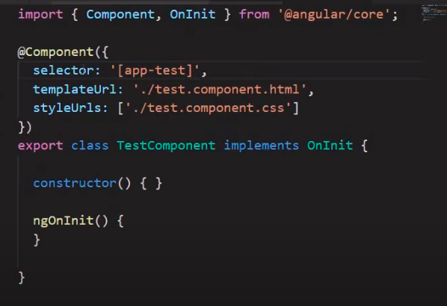 | 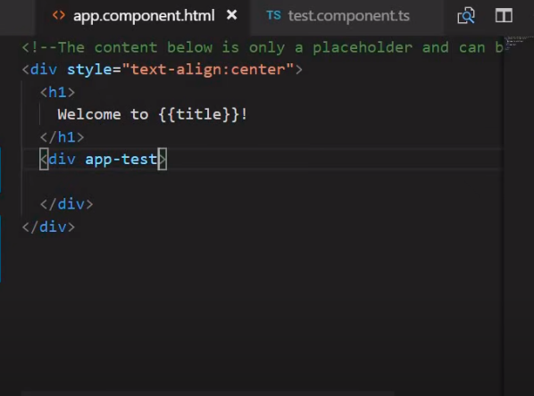
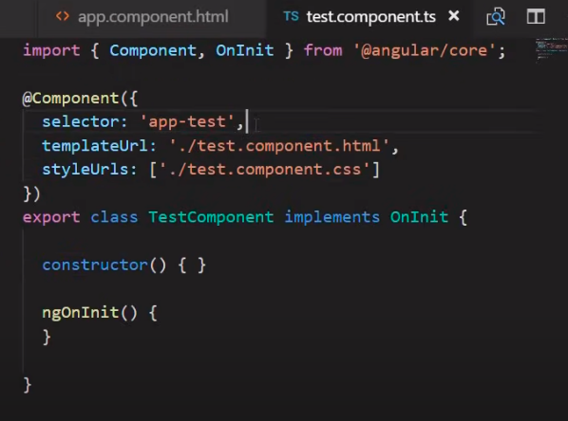 | 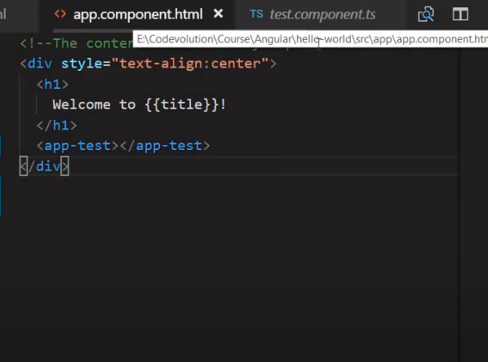
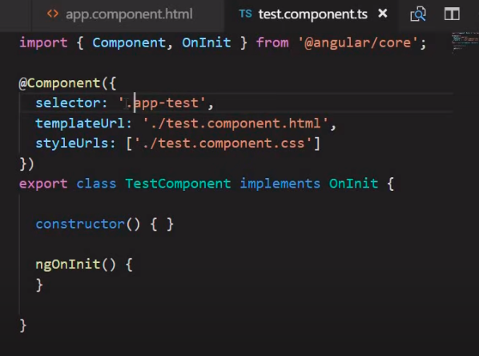 | 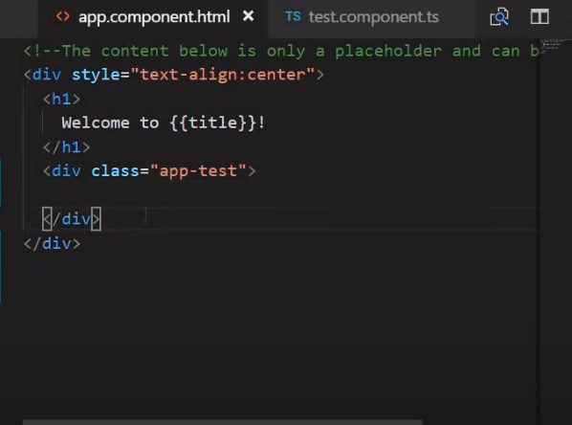

2.Inline html and inline css

Inline html | 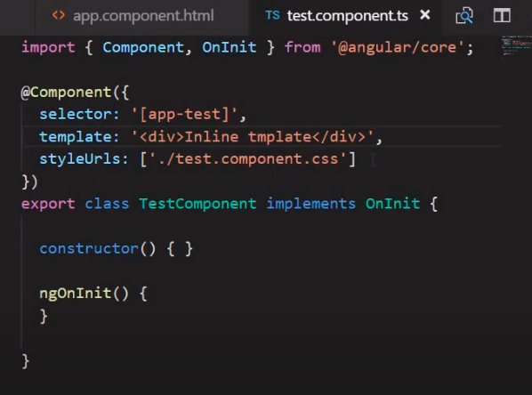
Inline css | 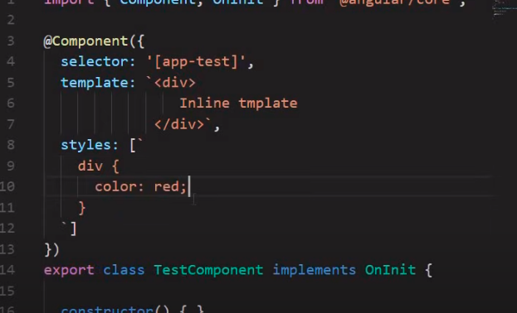

INTERPOLATION

We make a new component and then add html to the app component and then call the test component in app. | 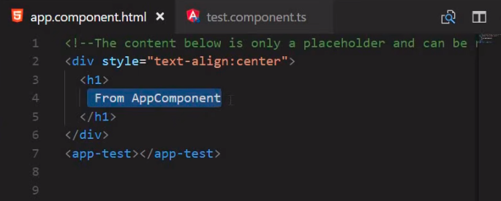
Now we make app.component.ts with inline template. | 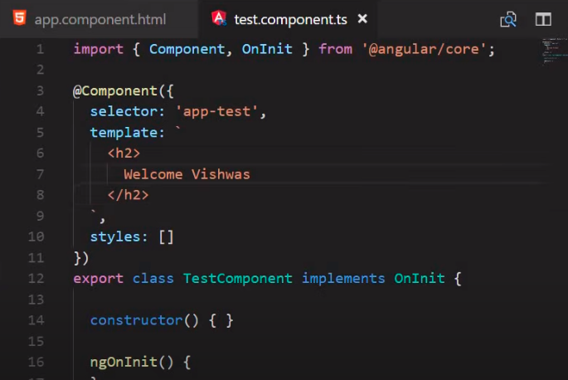
Making use of the class variable in html is know as interpolation. | 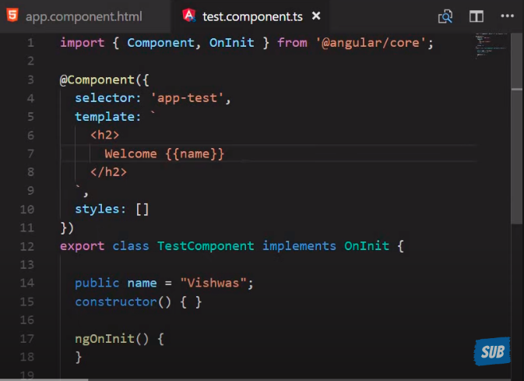
Declaring variables and strings | 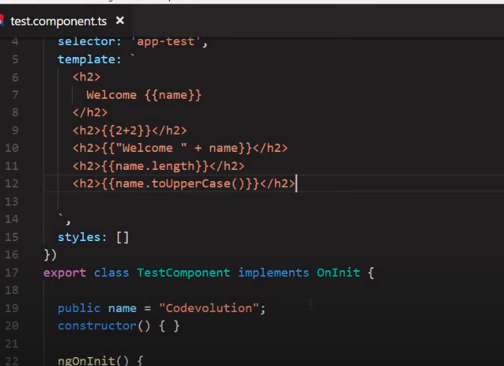
Using a function | 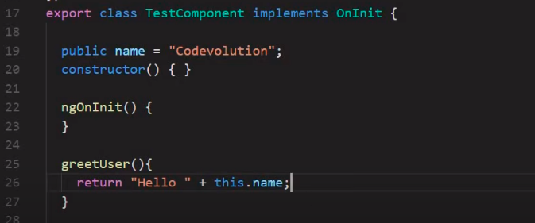  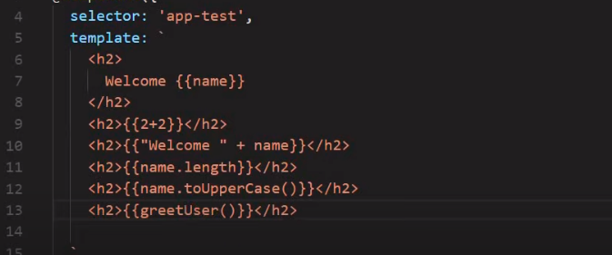

PROPERTY BINDING

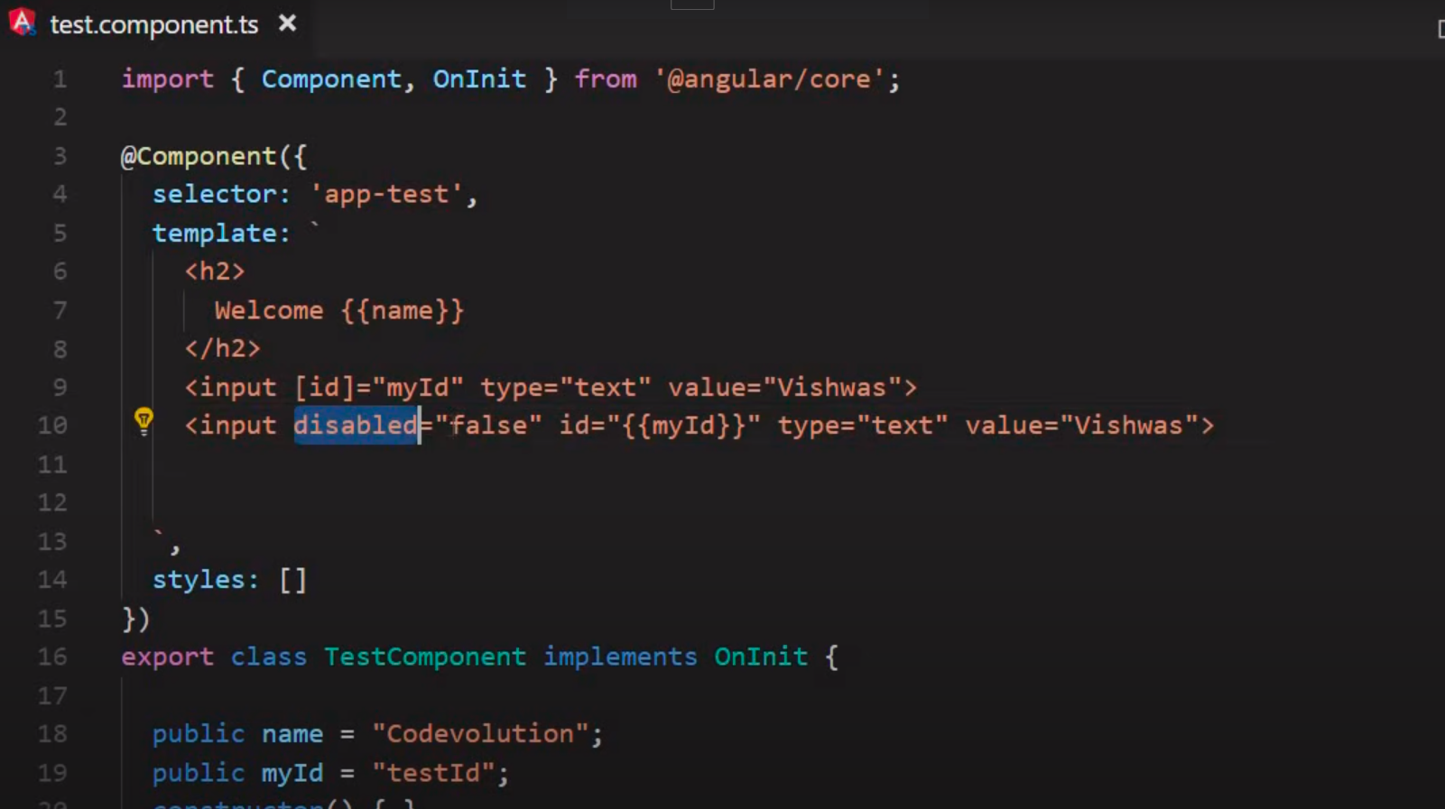
Declaring the value of property as it is.
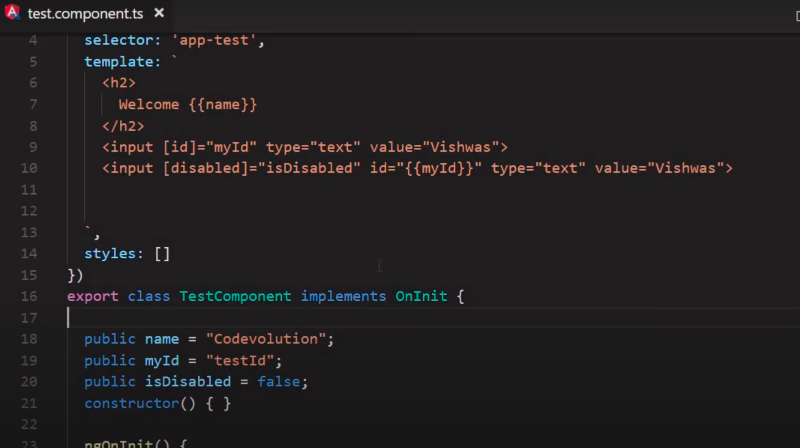
Using property from the class

CLASS BINDING
Binding the html element with a class and css
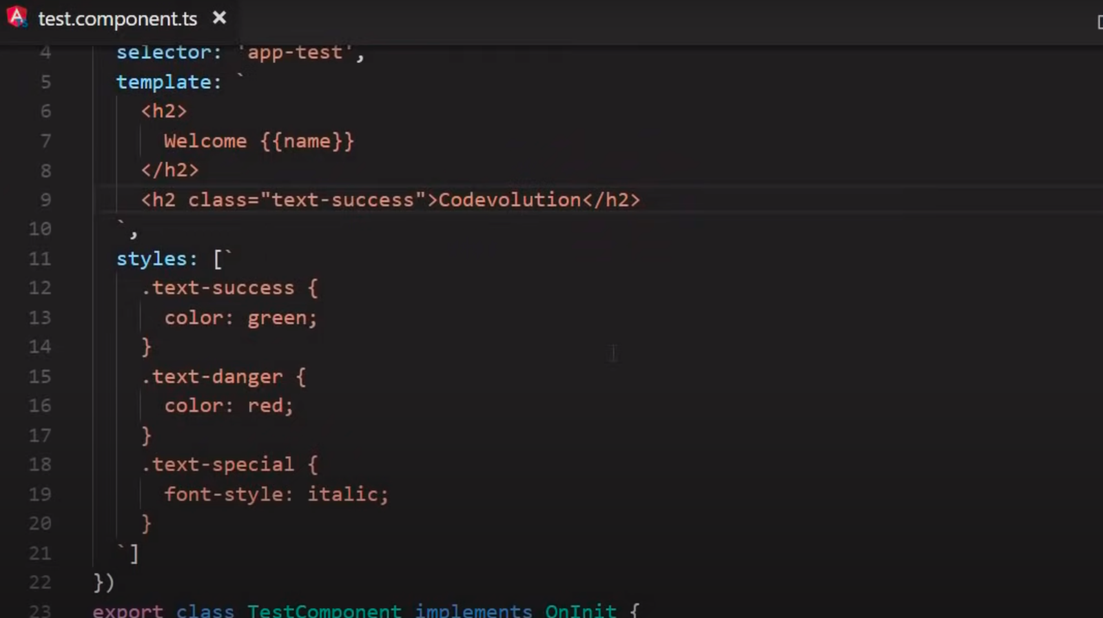

Binding a class with a value | 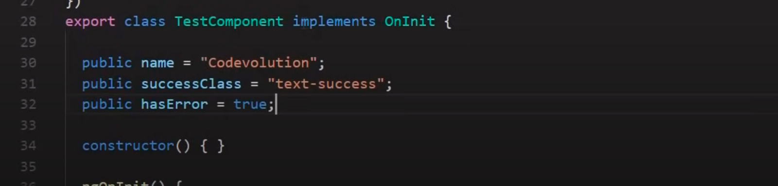  This binding is done like this in html code.  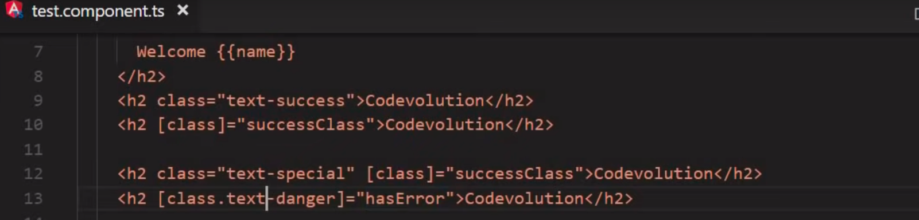
Example 2  using [ngClass]  Explanation  here the component <h2> will have the class applied from the object “messageClasses” which will have the value as true.thus in this example text-success and text-special will be applied. | 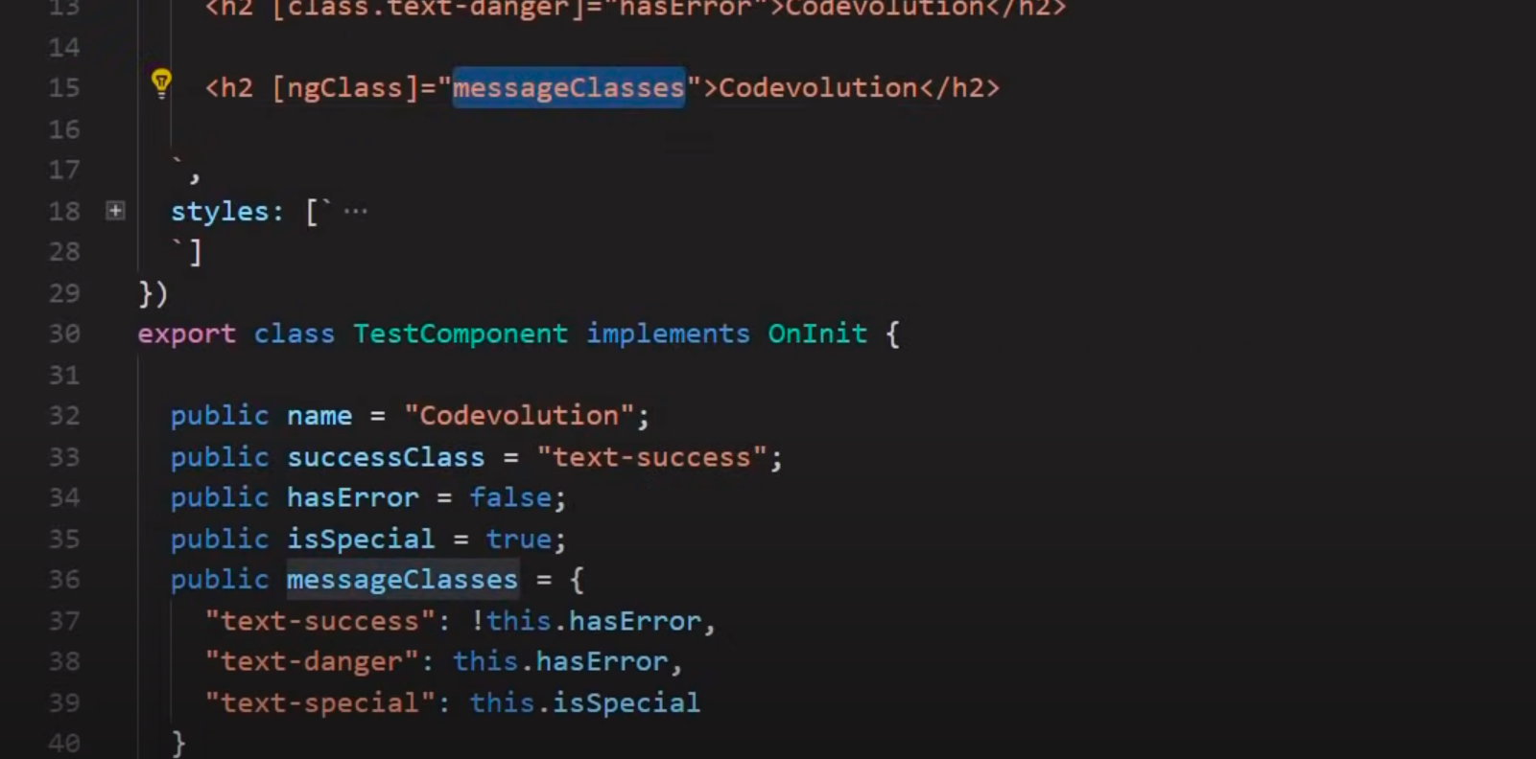

STYLE BINDING

Binding a style to a html element | 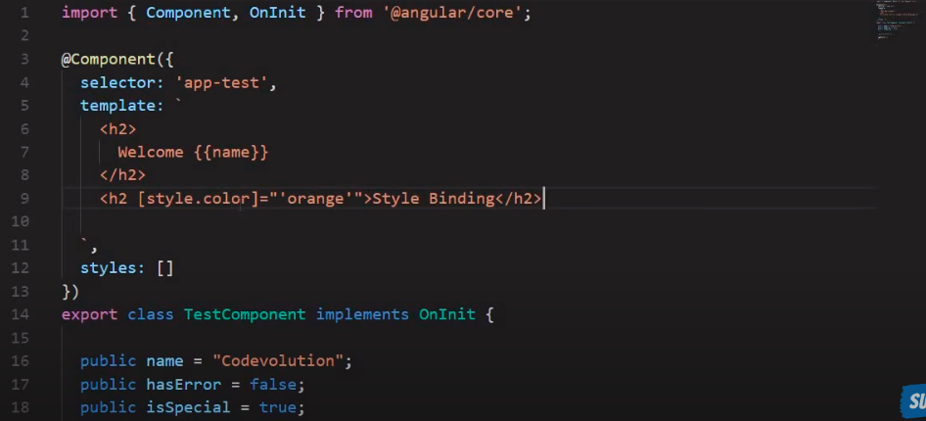
If hasError is set to true then we will apply red color else it will be green. | 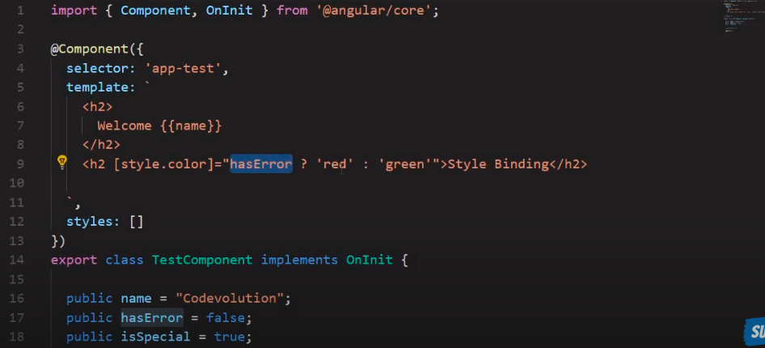
Property binding with the class  using [ngStyle] | 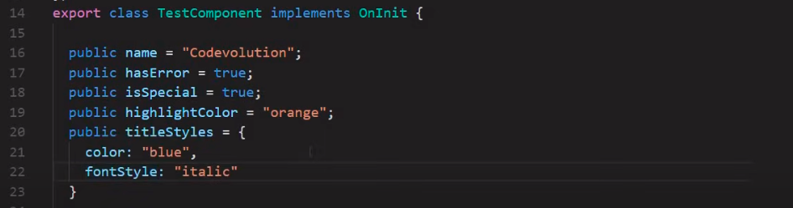  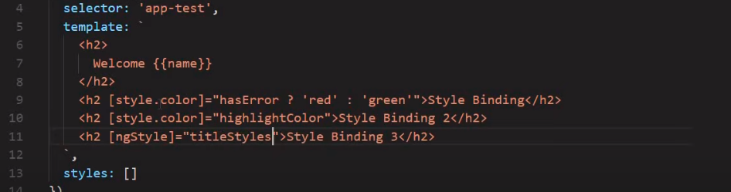

EVENT BINDING
to move values from template to class is called data binding

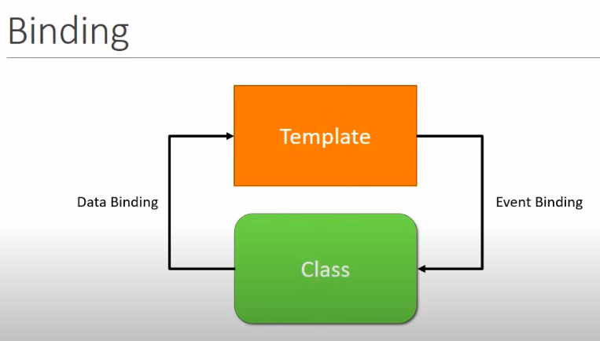

Event binding to a button | 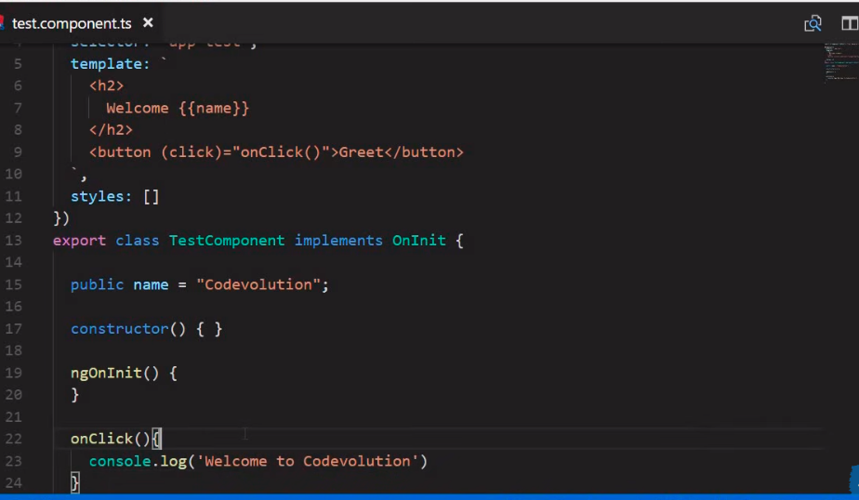
Event binding by sending a property | 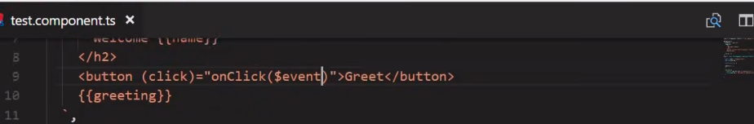  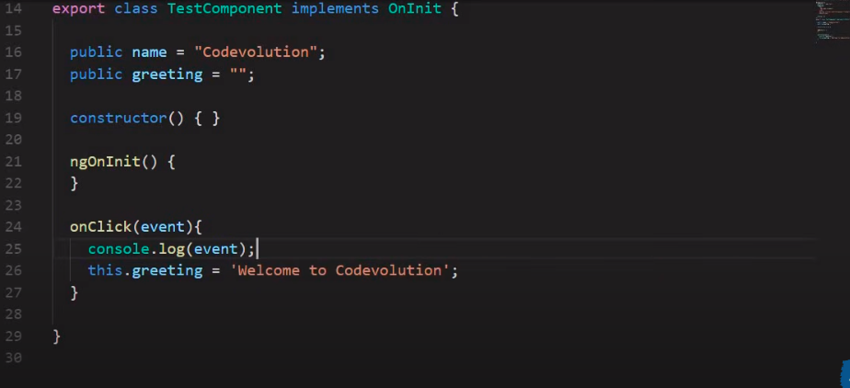

TEMPLATE REFERENCE

We want value #myInput to be bind to the text field.When the button is clicked then the value in the “text” field will go in myInput and onClick the logMessage() method with the myInput value will be called. | 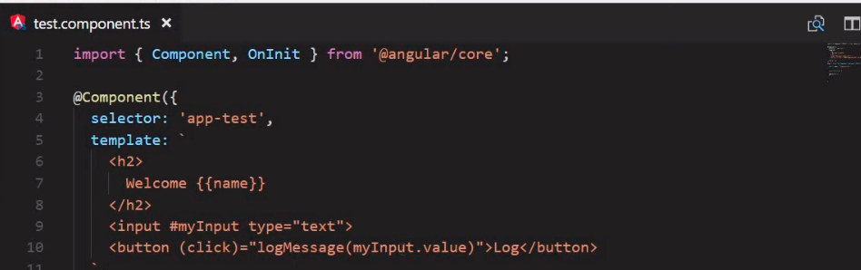
TWO WAY BINDING

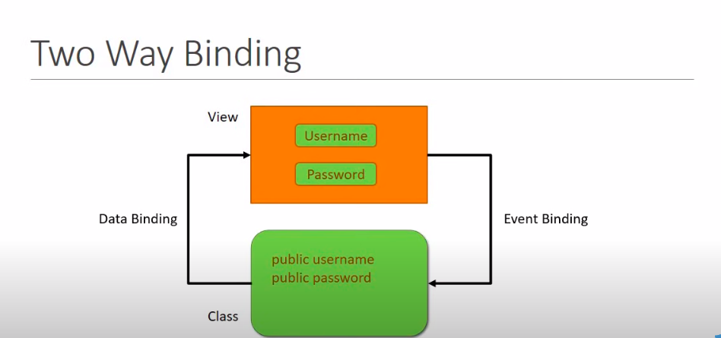

for 2 way binding angular provided ngModule directive

NgIf directive

*ngIf -->if value is true then h2 will be seen on the page but if it is false then h2 will not be seen on the page..When it is false then you will not be able to see the element in the inspect dom. | 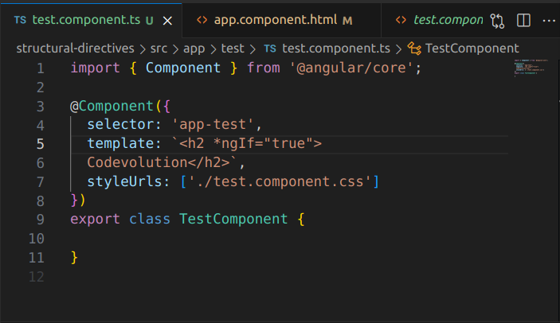
When the value of displayName is false then first h2 will not be printed on the sreen rather he else which isnamed as elseBlock will b displayed. | 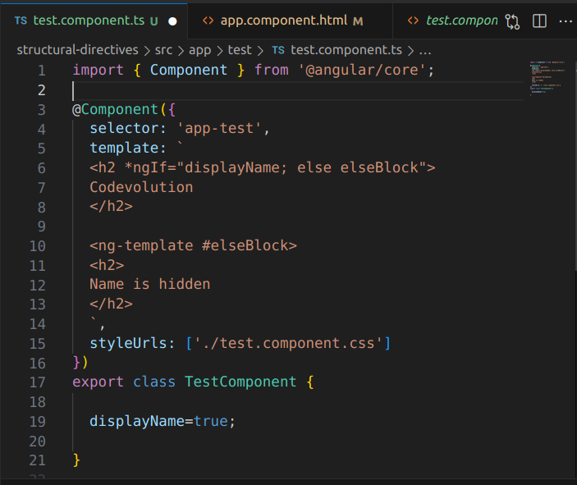
Here it is read as <div> will render the #thenBlock when displayName is true else if disaplyName is false then the #elseBlock will be rendered. | 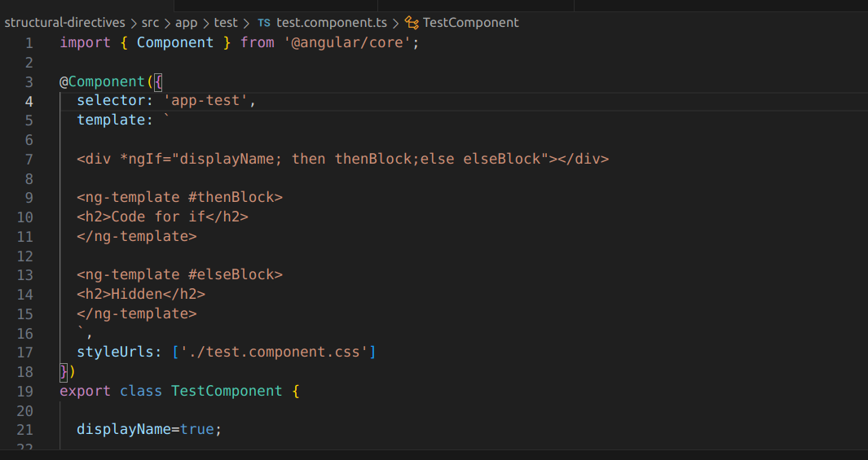
NgSwitch and ngFor directive

NgSwitch will switch to a case when as selected. | 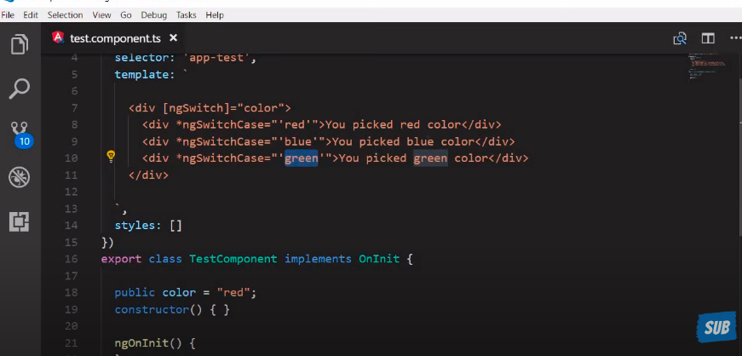
ngFor | 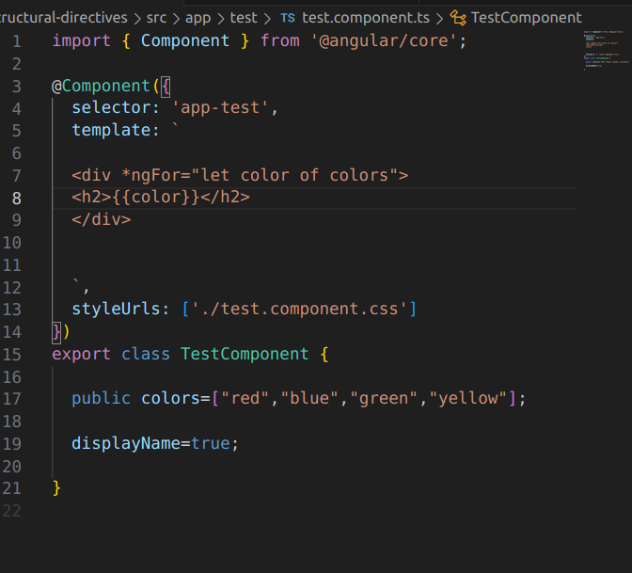

COMPONENT INTERACTION

the components interact with each other and share data.
Child sends data to parent using @Output decorator and parent send data to child using the @input decorator

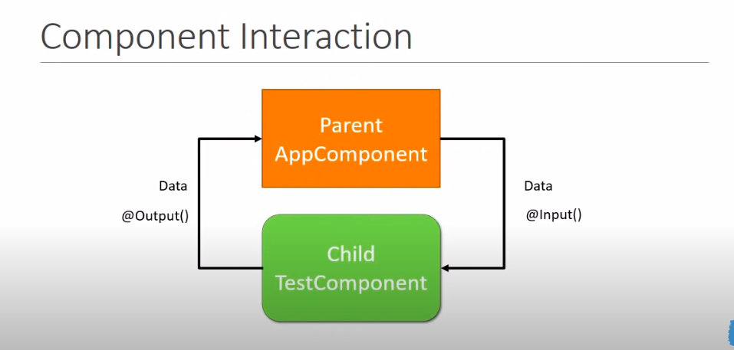
Sending data from parent to child.App-->app-test
First we will have a variable named as “name “ in the app.compoent.ts file | 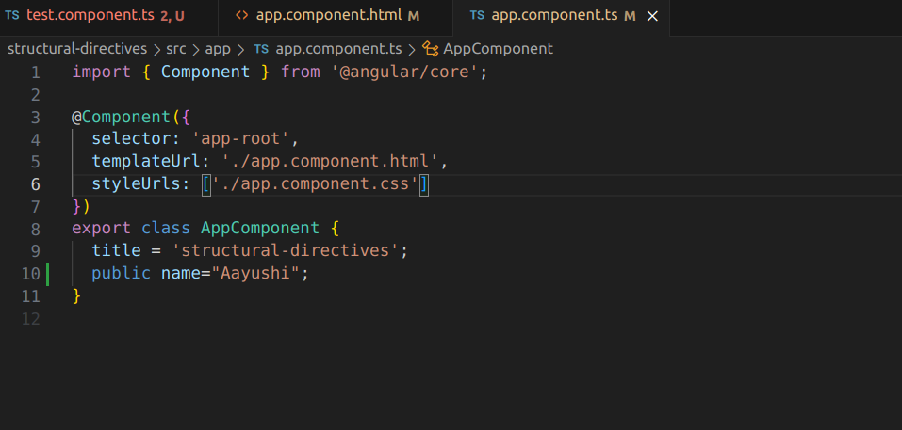
Then we will use that varibla ein the app.component .html while calling hte test compoennt we will pass it there | 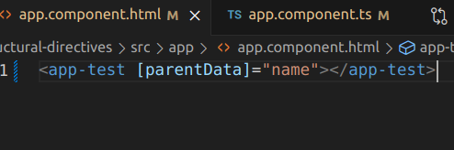
Now the test.component.ts fiel will take as input the varible passed from the app-root parent to the test component. | 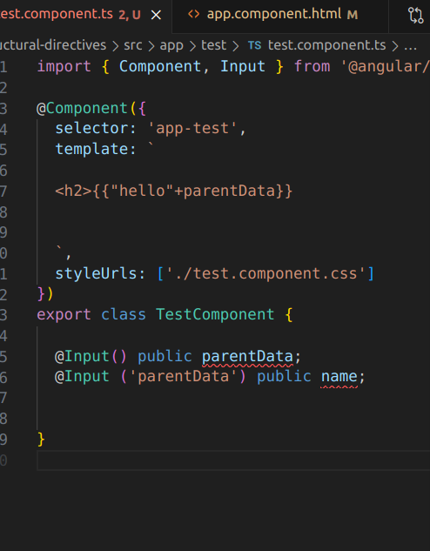

Sending data from child to parent
to send data from child to parent we will do as below:
We can have a fireevent function called on when a button is clicked.  Now childevent will send a message as Hey to the parent and the child compoennt sending to the parent will be marked with @Output(). | 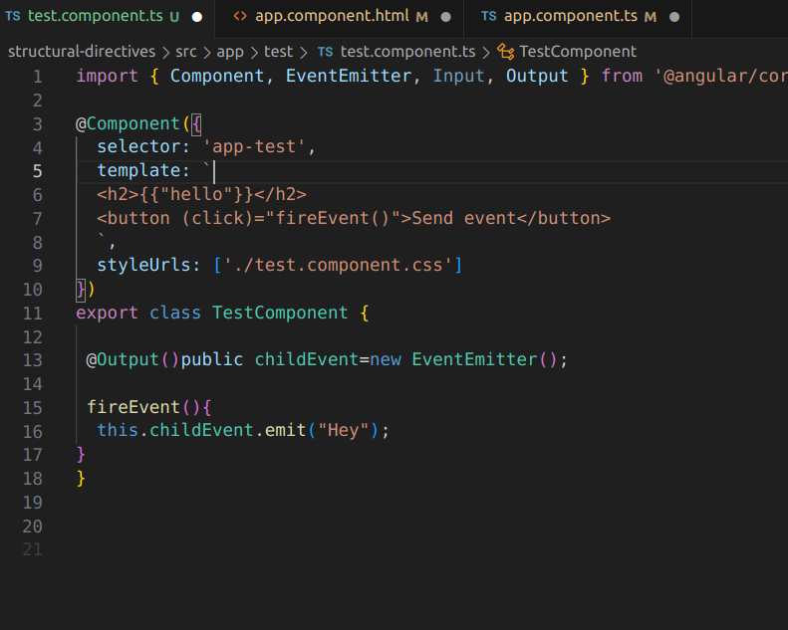
Parent will take the messag from the child. | 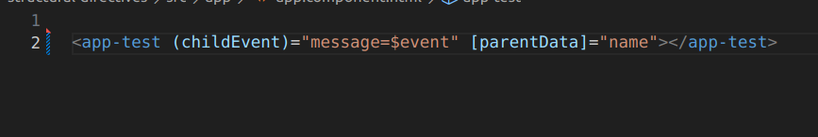
 | 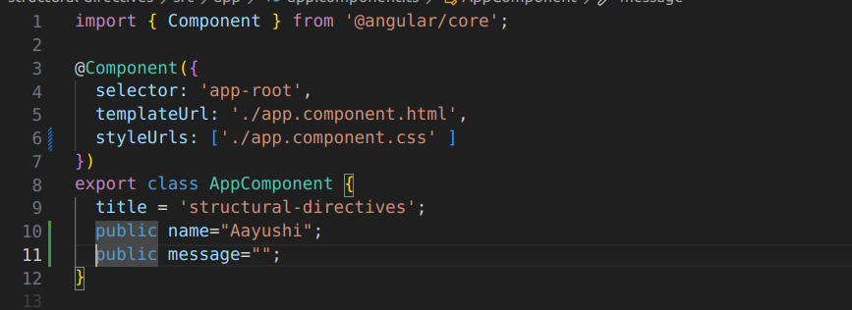

PIPES
pipes help to transform the data before dispaling tem on the screen
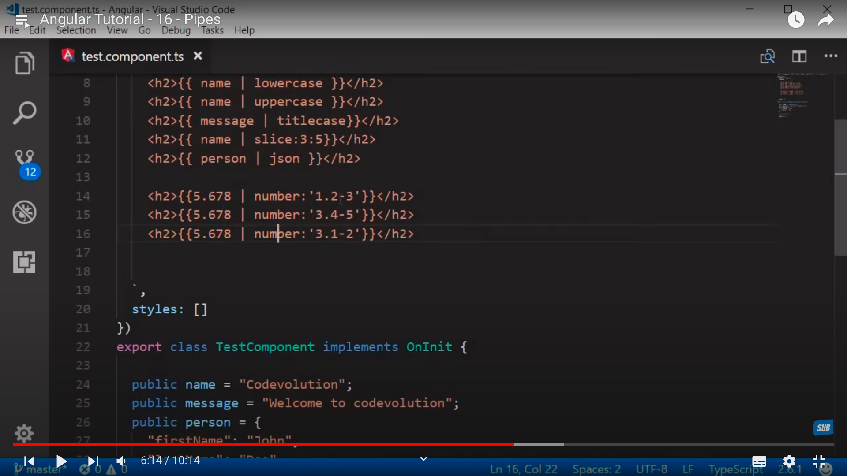
SERVIESC

first we will make a na employee service using the command ng g s employee-service
First we will make an employees array in the employee Service. | 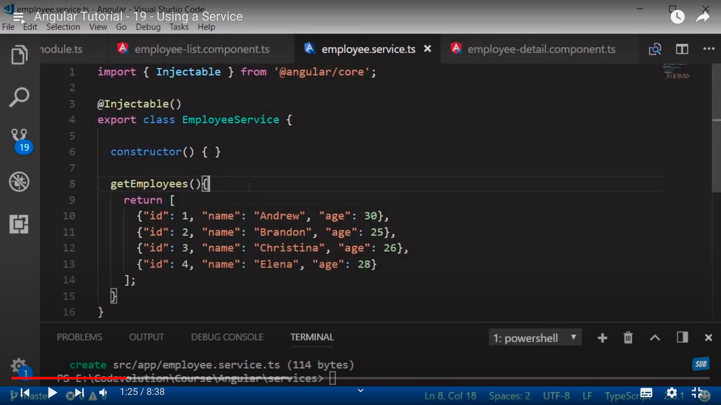
We will call the employee service in the constructor of the emplloyeelist component | 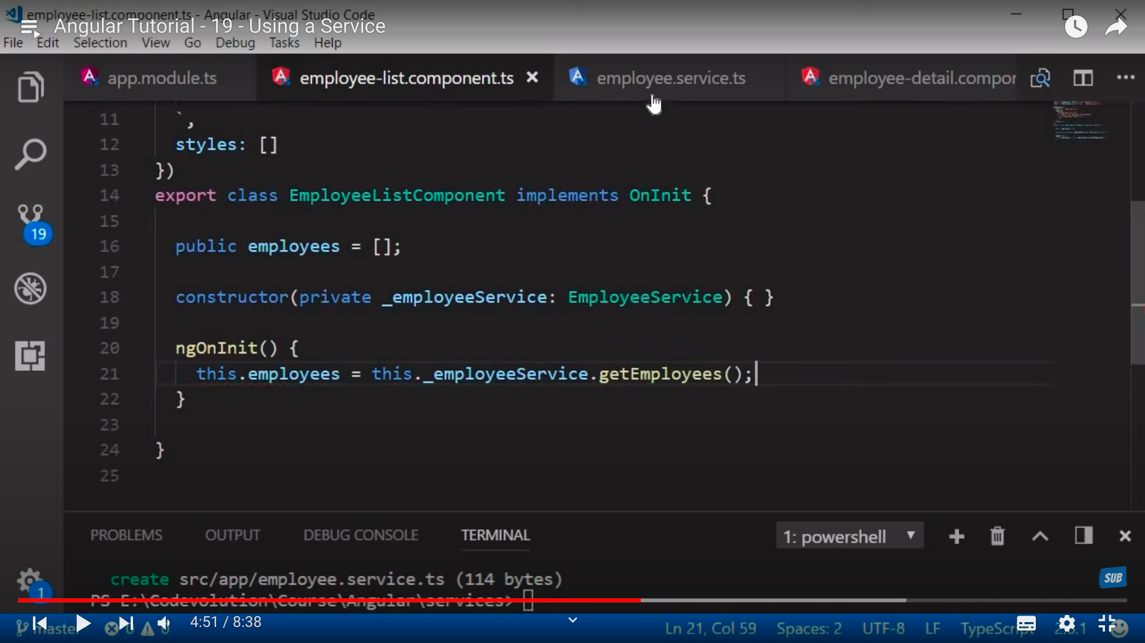

HTTP AND OBSERVABLES

in the employeeService we have a getEmployee method and in that we are making a static list retun but now here we need to make ahttp call. | 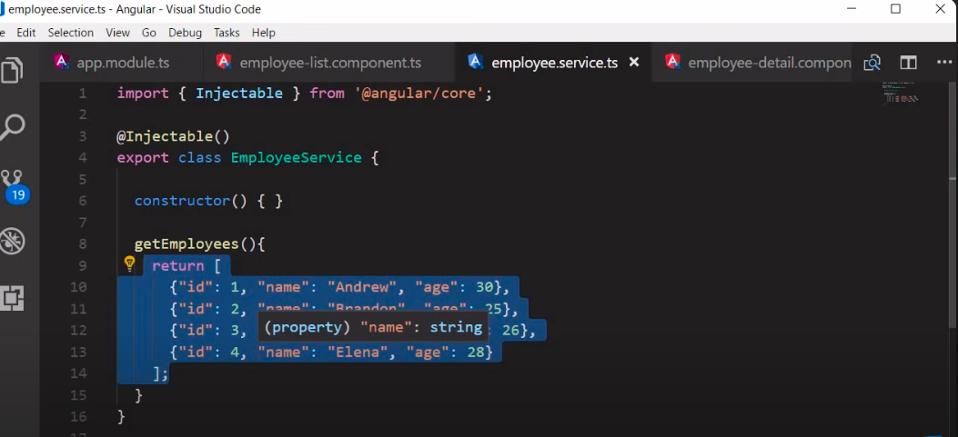
HTTP MECHANISM | 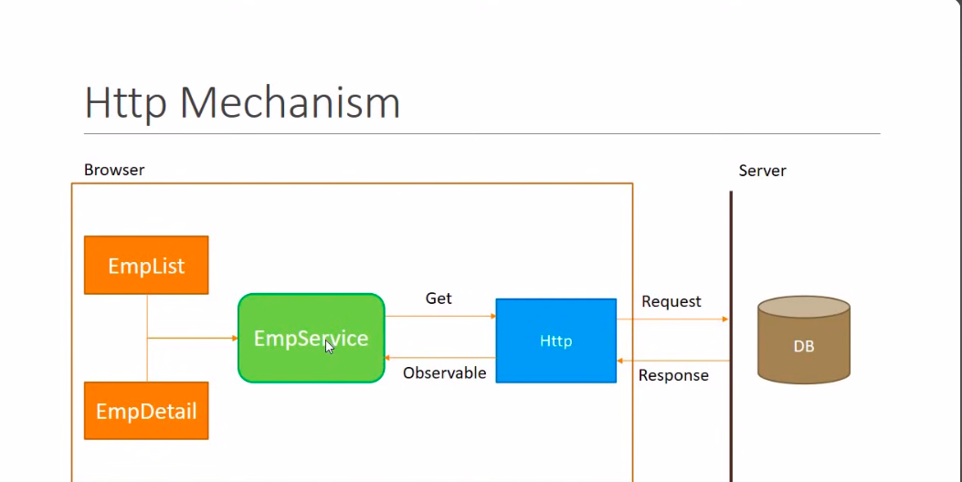
OBSERVABLES.  The houses who have subscribed to the newsapaper company will getthe newspaper.  In teh similar manned we have an observable who will provide data from the db to the emloyee servcie which in turn will be provided to EmpList/EmpDetail component | 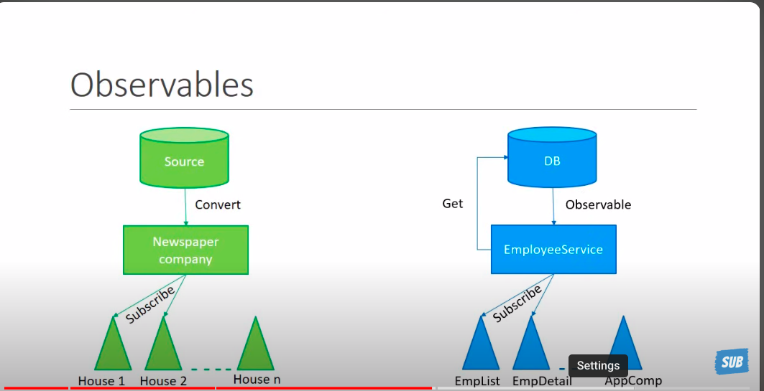
What is an observable.  The data in observable format is of no use to us so we will convert it into usable type. | 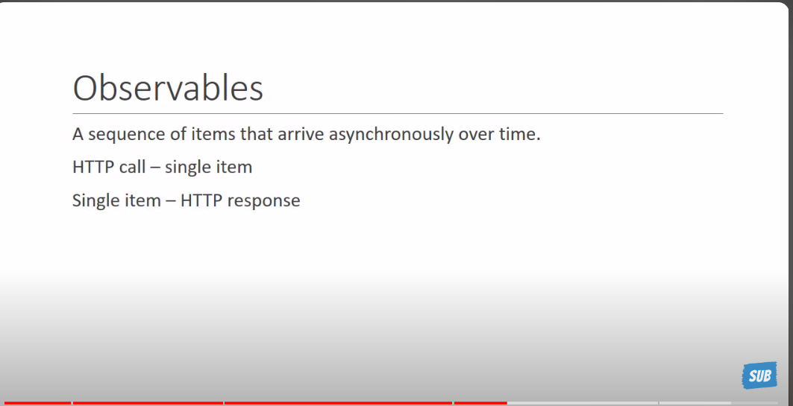
Http observables steps. | 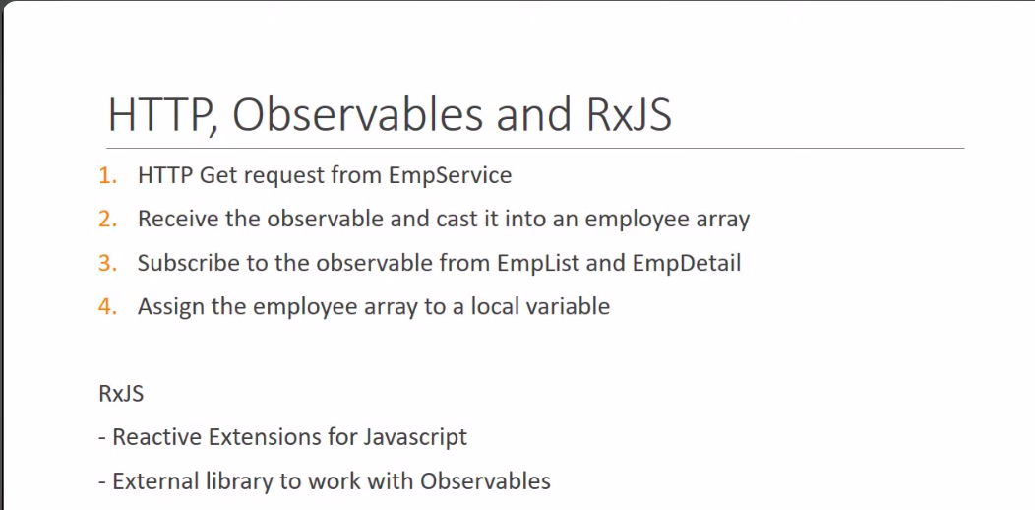

The above 4 steps will be used as below:
How to use observables
1.We will first import httpClient in the module | 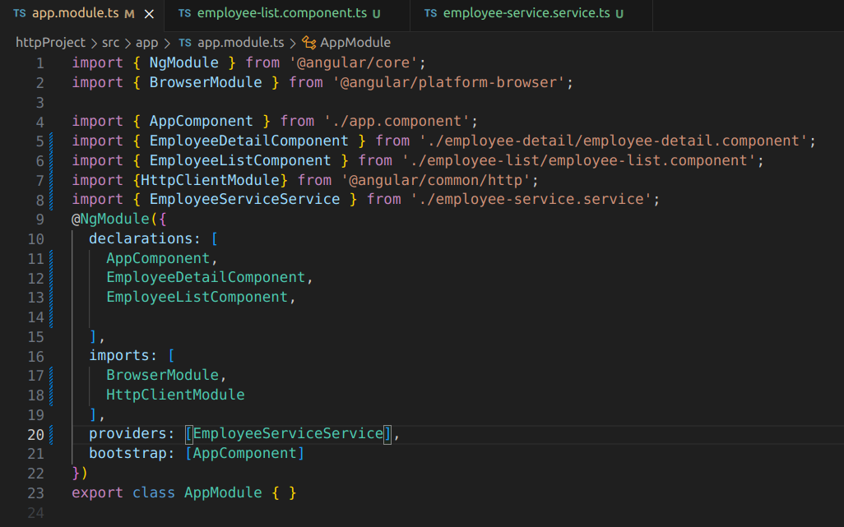
We make a file to make a call to in th eassets folder | 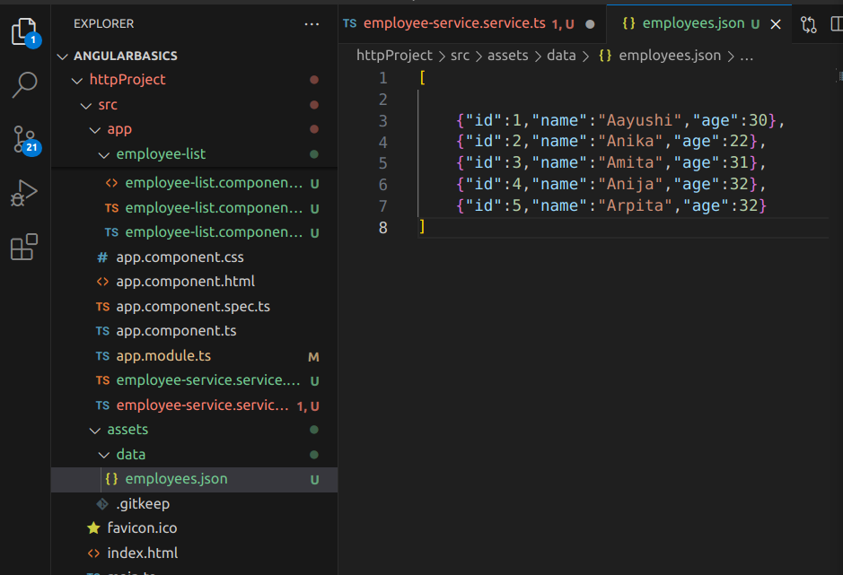
1.Now we make a service and make a call to the above file in the employeeService class.The url will return us an Observable which needs to be converted to some employee object so we will make an interface. | 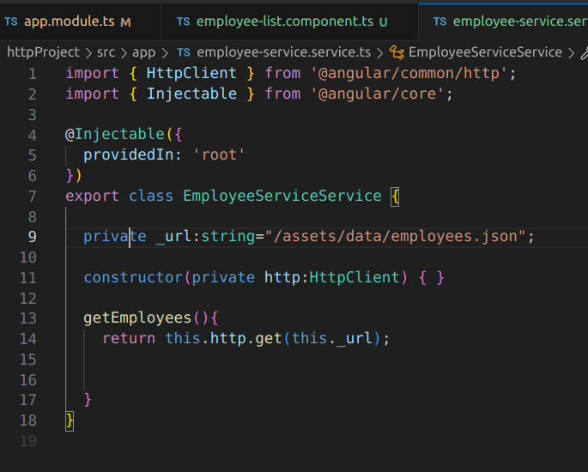
Now we make an employee interfcae | 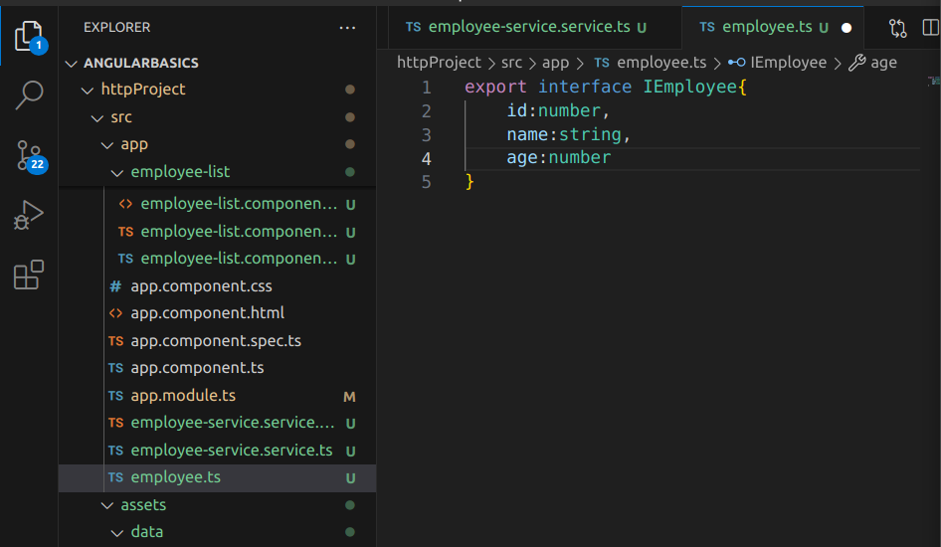
2.We add observable to an employee array | 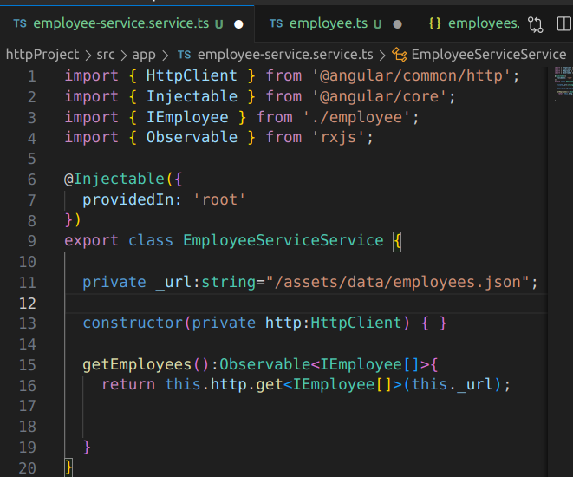
3.subsribe to observable from empList.  We have an employee service who will retrun an observable and to get data from it we neeed to subscribe to it to get the data. | 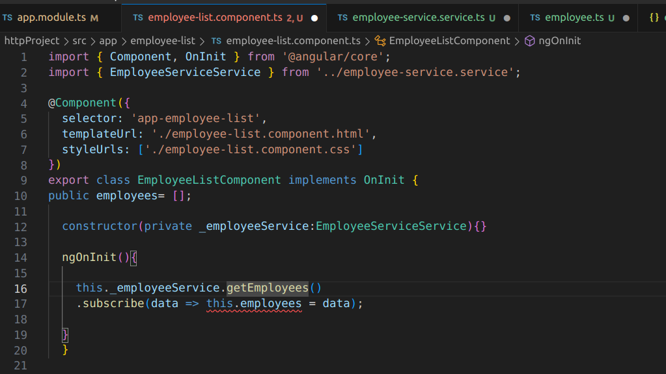

ROUTING AND NAVIGATION
the steps that we will follow for routing are as below

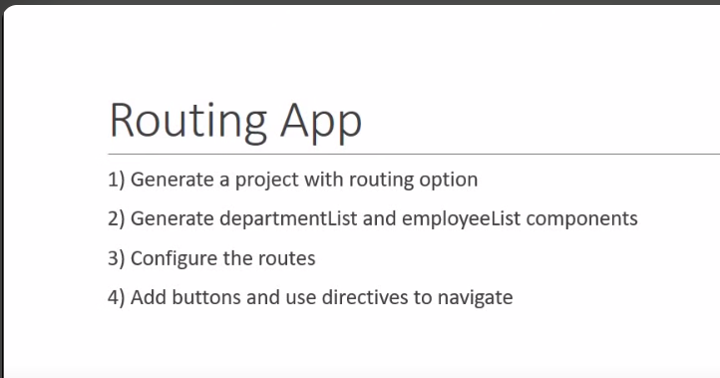
|
Line no 6 is imp in our index.html so that our application knows how to root | 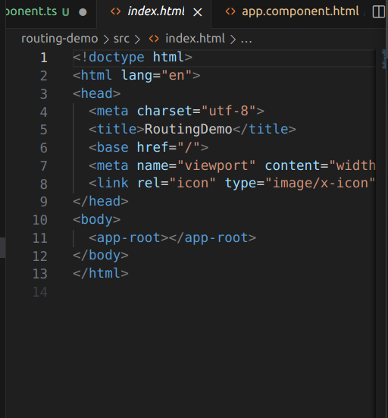
This file will contain the routing info of our application | 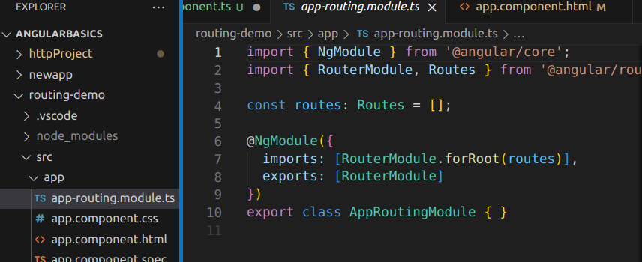
Now app.module.ts will consist of the import AppRoutingModule to import the routing. | 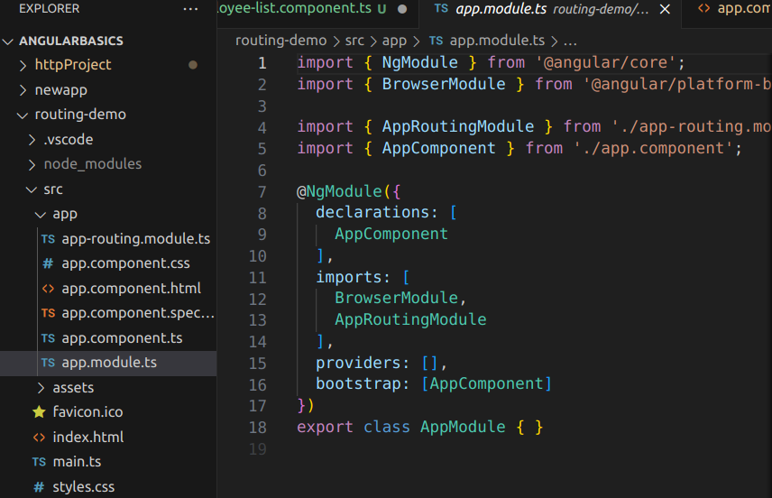
We generate a department-list component and an employee-list component | 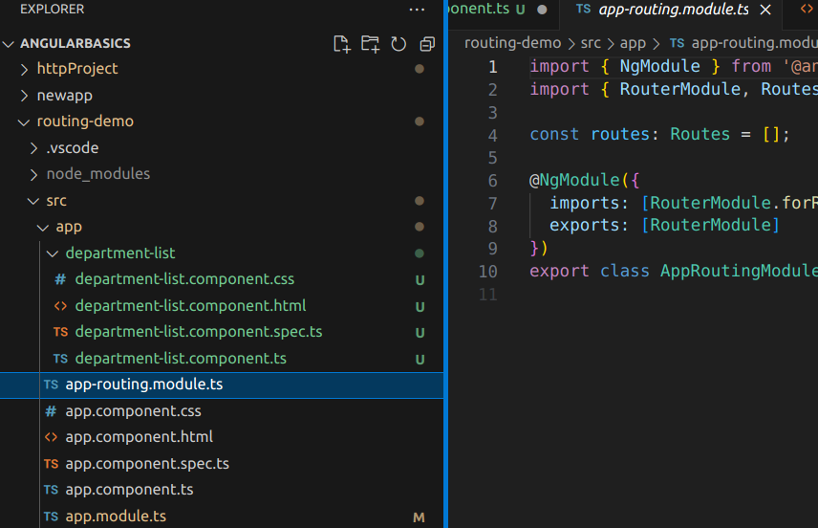
Now we will make a constant to export to the app-module folder and then we will import it in the modules folder so that we do not have to write the code again and again | 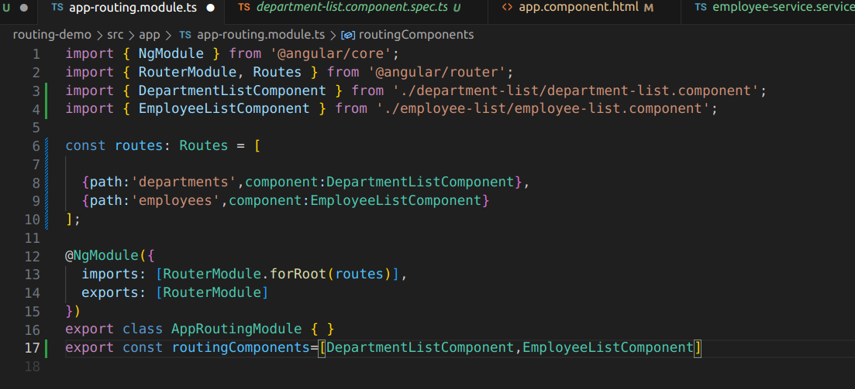
Lnow in app-module we have line no 10 and 4.  whatever routing we have to add we will add in the routing components | 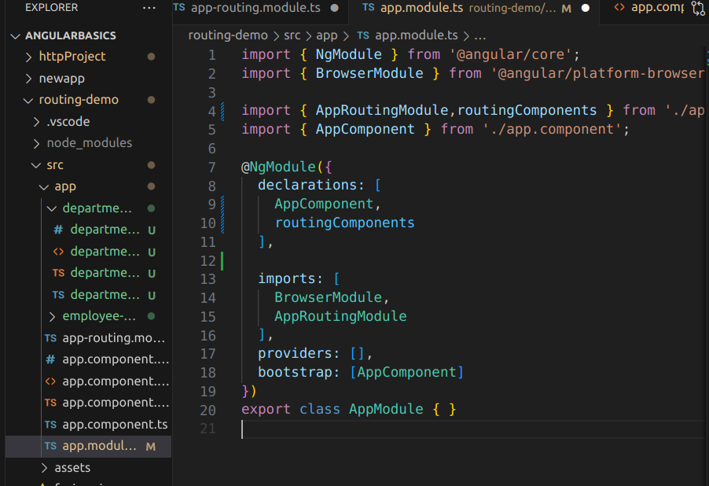
Now we will call them in app.compoennt.html file | 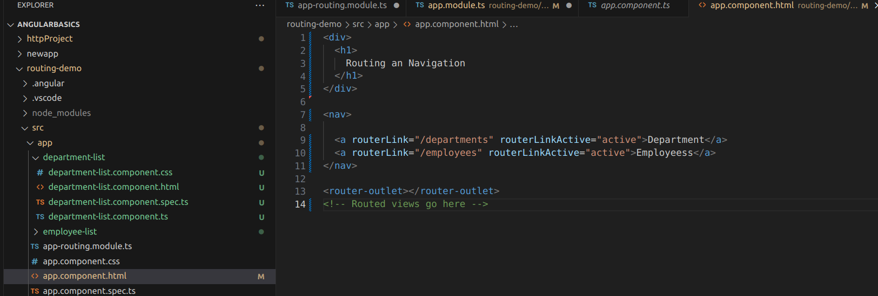

Rotue parameters
We will add a list to the department component | 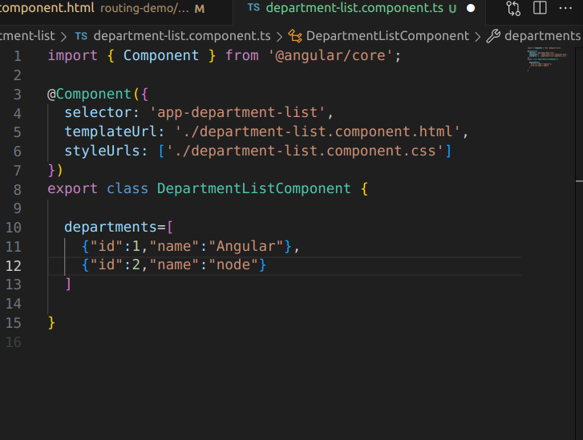
In the view we will iterate over each dept | 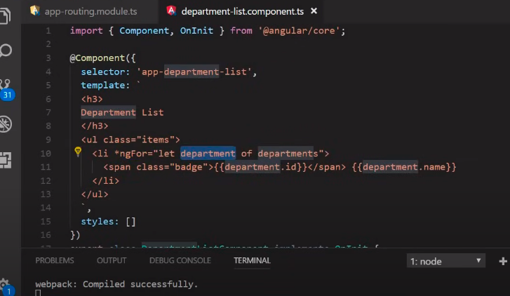
We want that when we click on 1.Angular then the url shoudl change to angular1 | 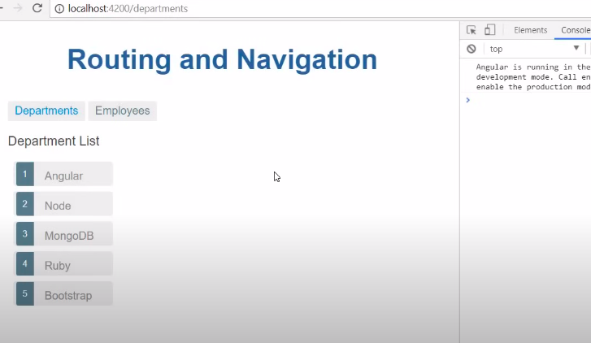
Specifying the route in the routing-module.ts file | 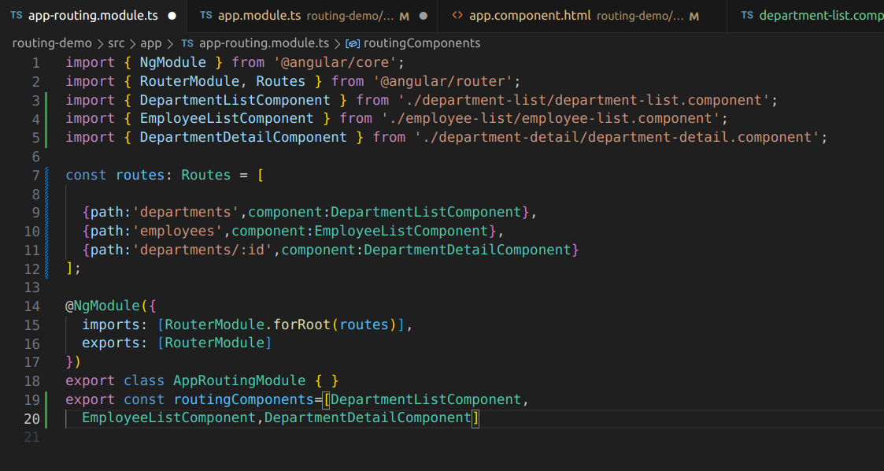
Here we mention that onselect of adepartemnt the method onSelect will be called which will route us to departements/id of hte one chosen which is mentioned in the picture abobve | 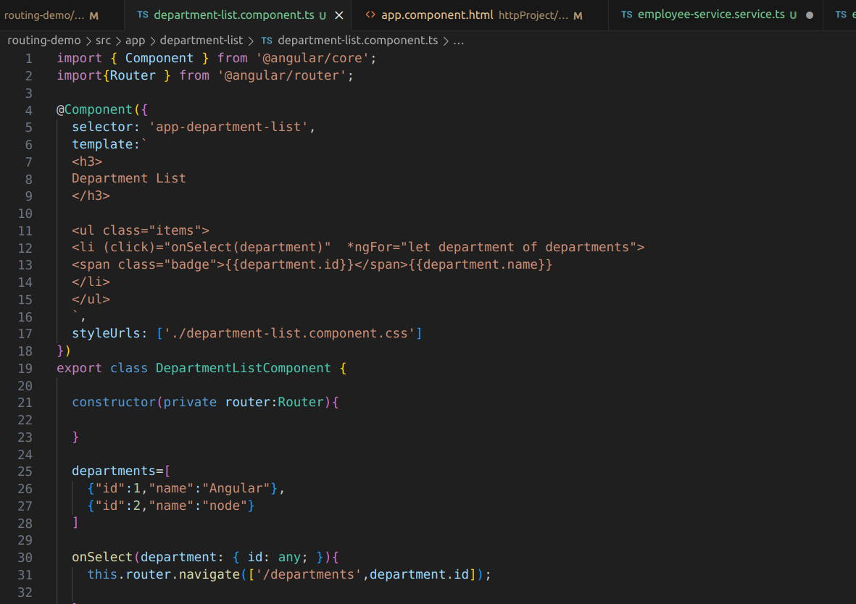

ANGULAR FORMS

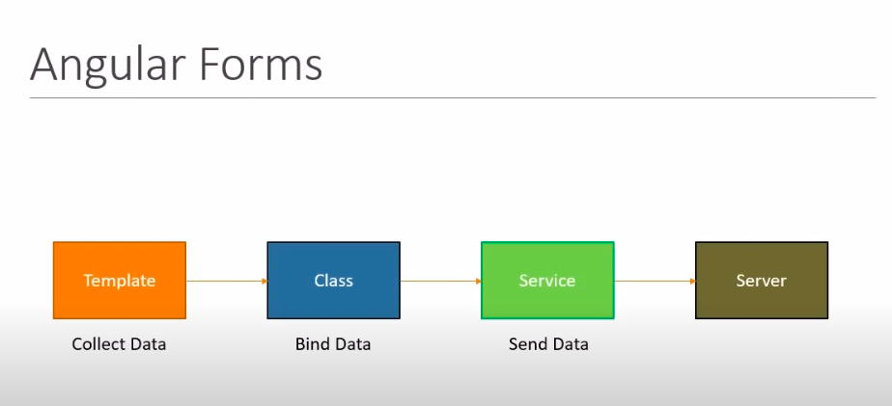
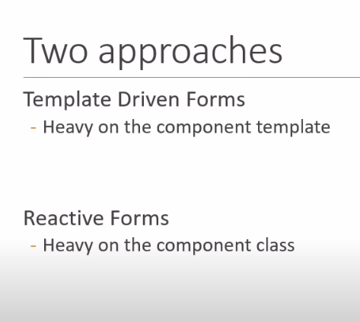
TDF APPROACH
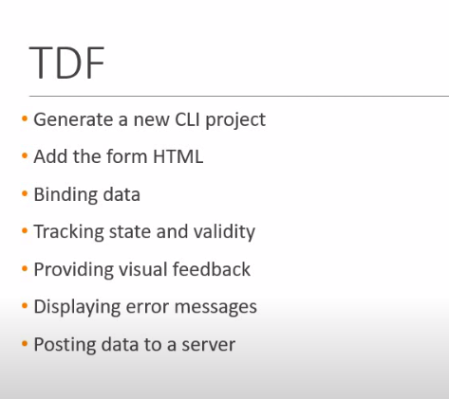

ANGULAR FORMS

First of all we make an html form | 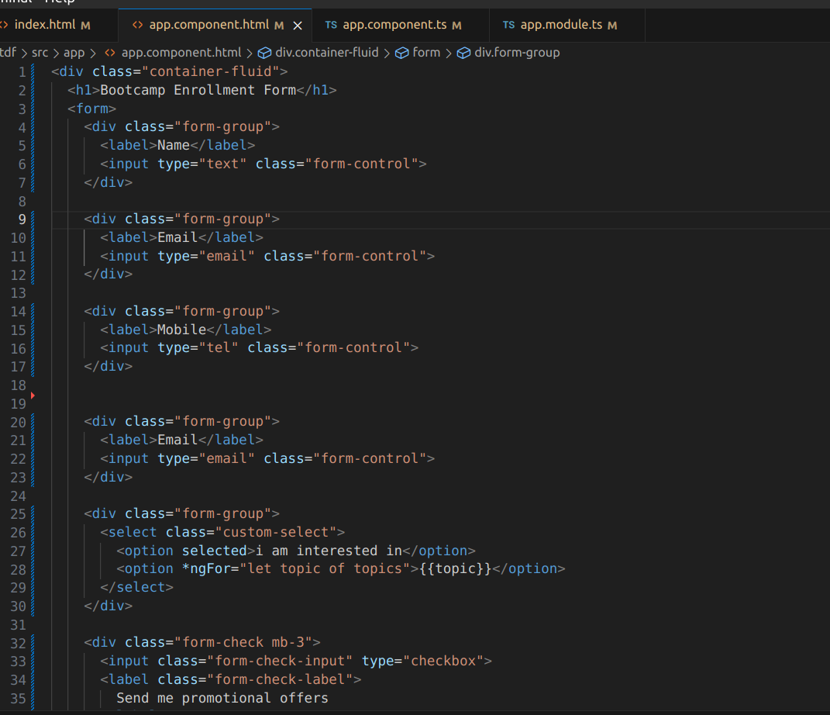
We want to egt the values that are being filled into the fields then in that case we will use the ngModel | 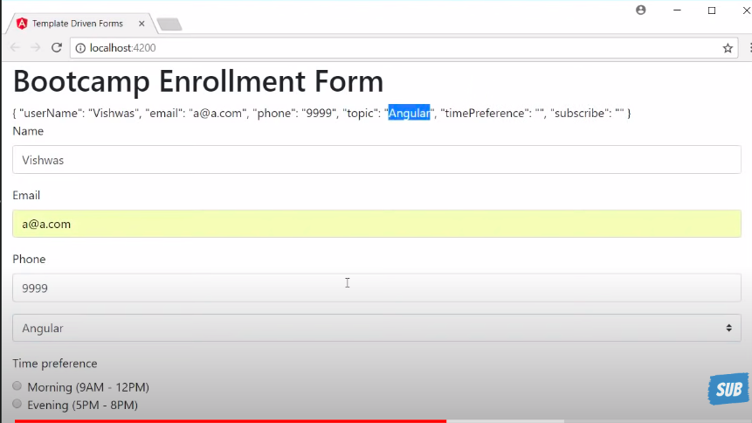
The code for the form is shown alongside | <div class="container-fluid">  <h1>Bootcamp Enrollment Form</h1>  <form #userForm="ngForm">  {{userForm.value|json}}  <div class="form-group">  <label>Name</label>  <input type="text" class="form-control" name="userName" ngModel>  </div>  <div class="form-group">  <label>Email</label>  <input type="email" class="form-control" name="email" ngModel>  </div>  <div class="form-group">  <label>Mobile</label>  <input type="tel" class="form-control" name="mobile" ngModel name="">  </div>  <div class="form-group">  <label>City</label>  <input type="text" class="form-control" name="city" ngModel>  </div>  <div class="form-group">  <select class="custom-select" name="topic" ngModel>  <option selected>i am interested in</option>  <option *ngFor="let topic of topics">{{topic}}</option>  </select>  </div>  <div class="form-check mb-3">  <input class="form-check-input" name="offer" ngModel type="checkbox">  <label class="form-check-label">  Send me promotional offers  </label>  </div>  <button class="btn btn-primary" type="submit">Submit Form</button>  </form>  </div>
We can make a ngModelGroup to group some elements.  The elemenst grouped with ngModel group and named as address.  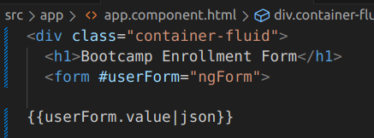  We can send the form data to the server using the {{userForm.value |json}} | 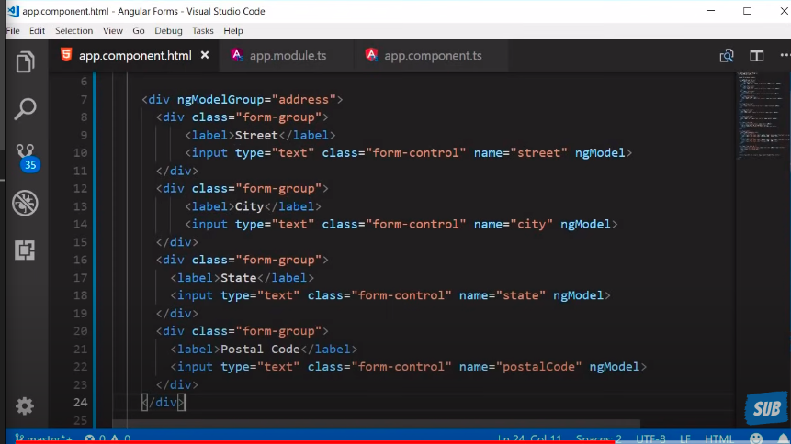
We generate a class udsinfg  ng g class User | 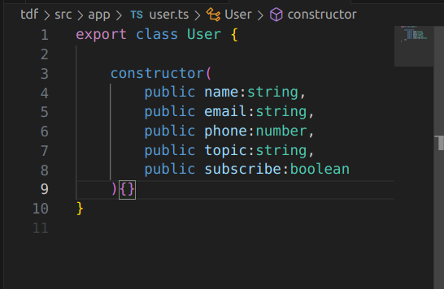
Sending data from component to the html | 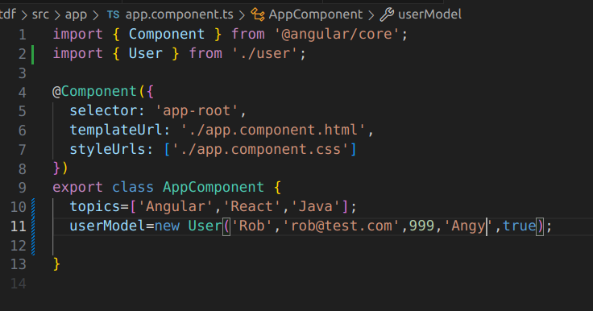
Getting in html | 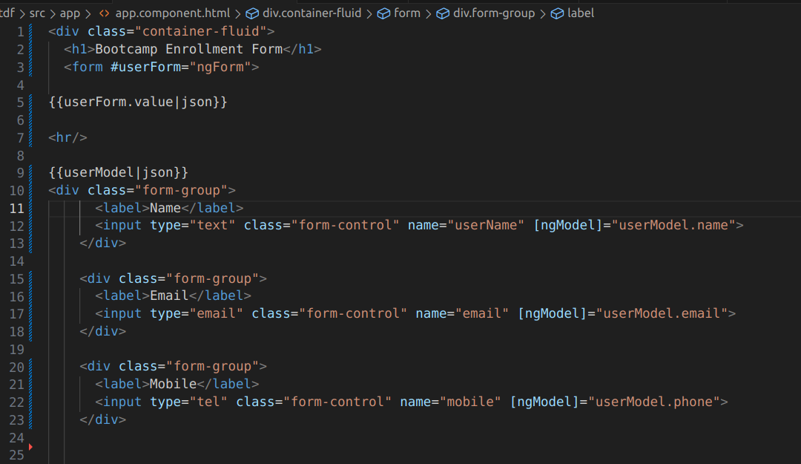
2 way data binding using [(ngModel)] | 

